Login in AWs management console:

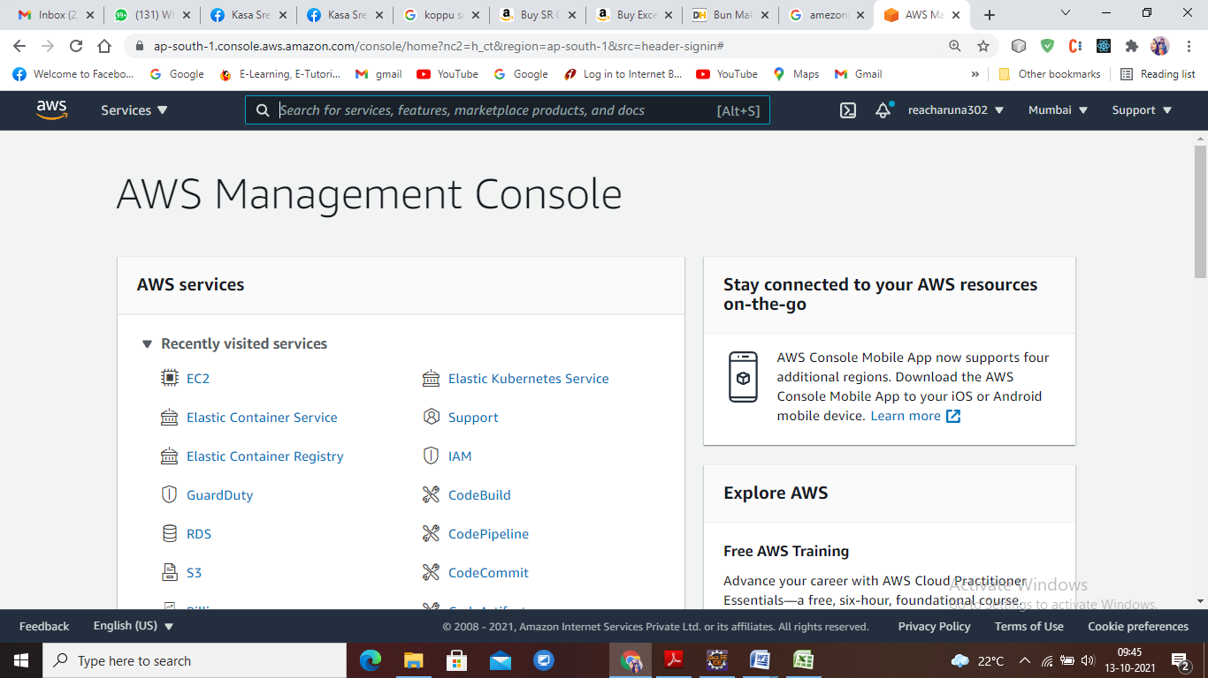

Search for Ec2 service or click on EC2

It will display the dashboard.

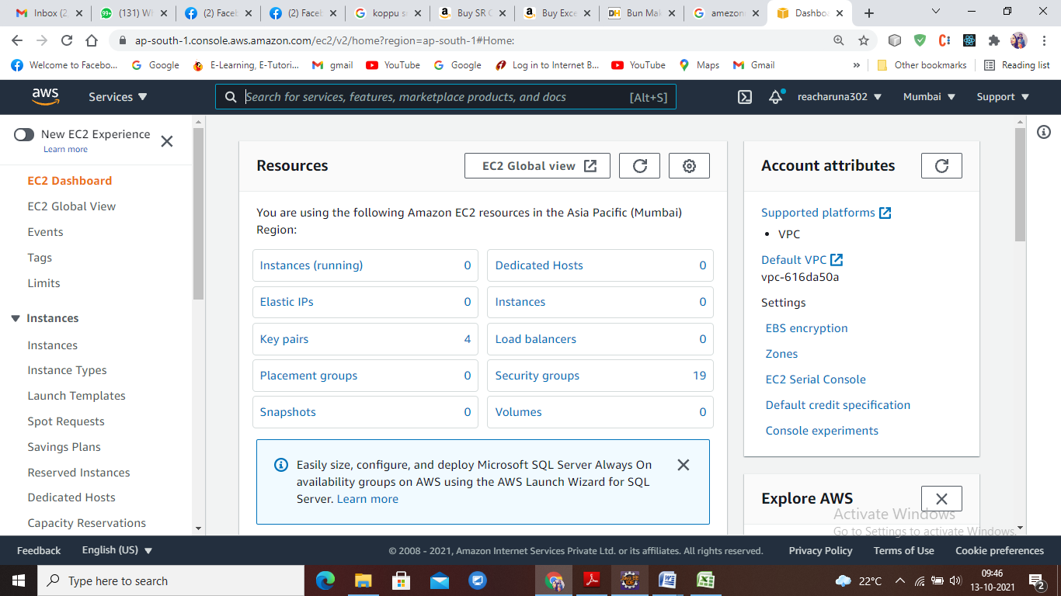

**Clink on Launch Instance:**

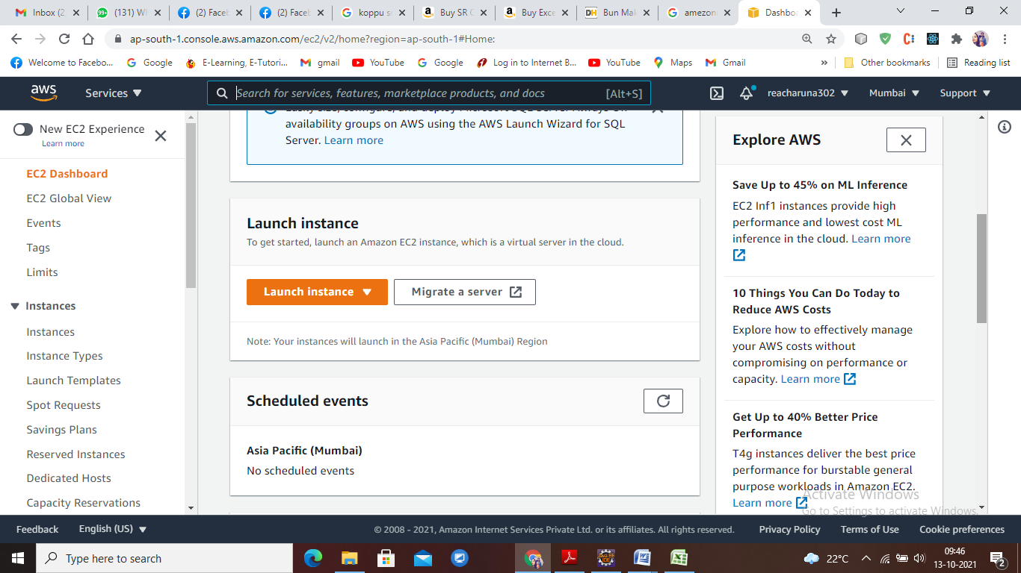

**Need to follow with 7 steps**

**1. Choose AMI**

2. Choose Instance Type

3. Configure Instance

4. Add Storage

5. Add Tags

6. Configure Security Group

7. Review

**Step1 - choose Amezon Linux Free tier**

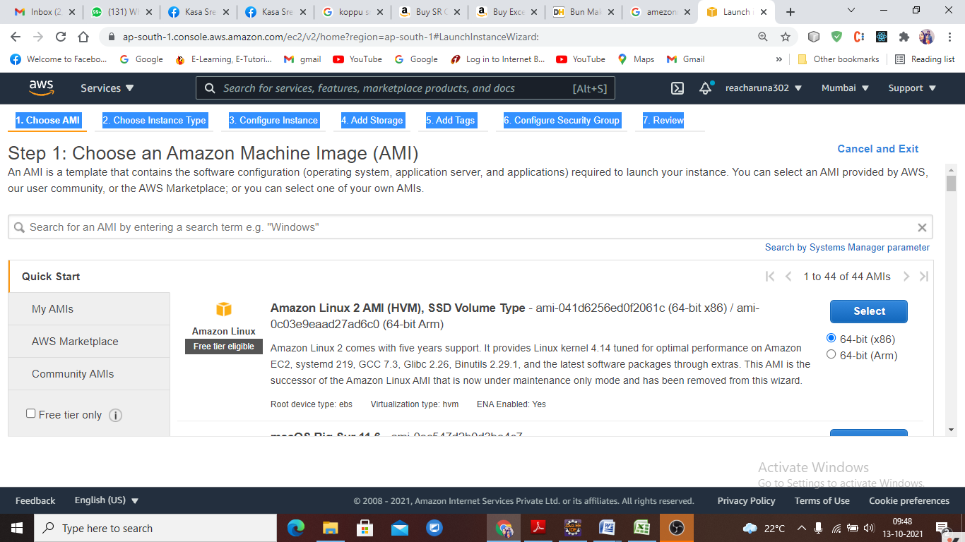

Step 2: Choose an Instance Type

Amazon EC2 provides a wide selection of instance types optimized to fit different use cases. Instances are virtual servers that can run applications. They have varying combinations of CPU, memory, storage, and networking capacity.

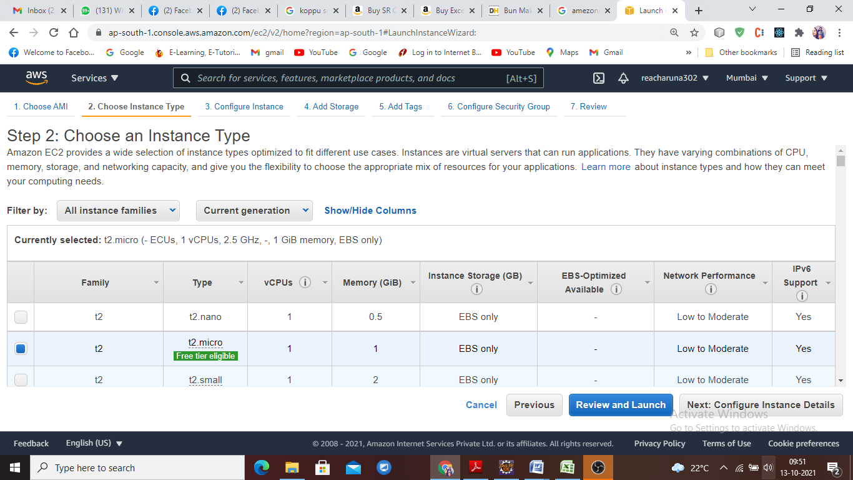

Step 3: Configure Instance Details

Configure the instance to suit your requirements. You can launch multiple instances from the same AMI, request Spot instances to take advantage of the lower pricing, assign an access management role to the instance, and more.

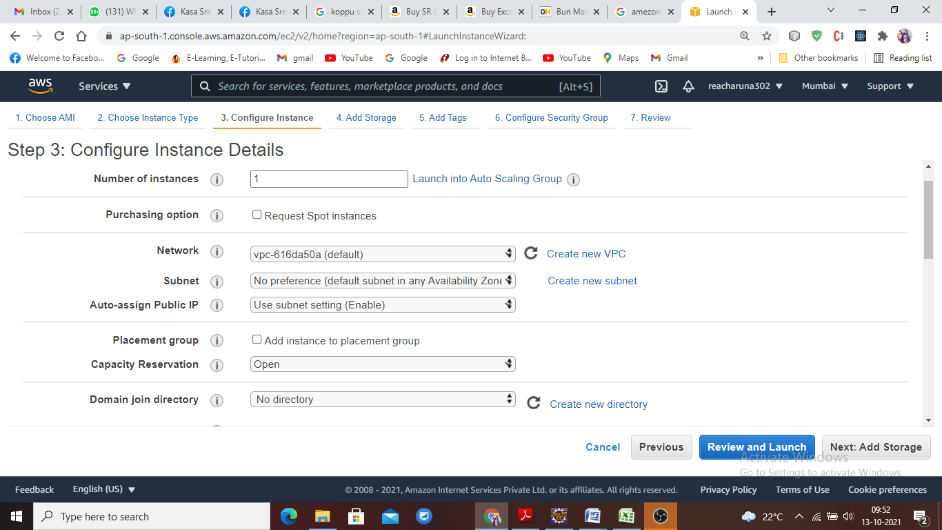

Step 4: Add Storage

Your instance will be launched with the following storage device settings. You can attach additional EBS volumes and instance store volumes to your instance, or edit the settings of the root volume. You can also attach additional EBS volumes after launching an instance.

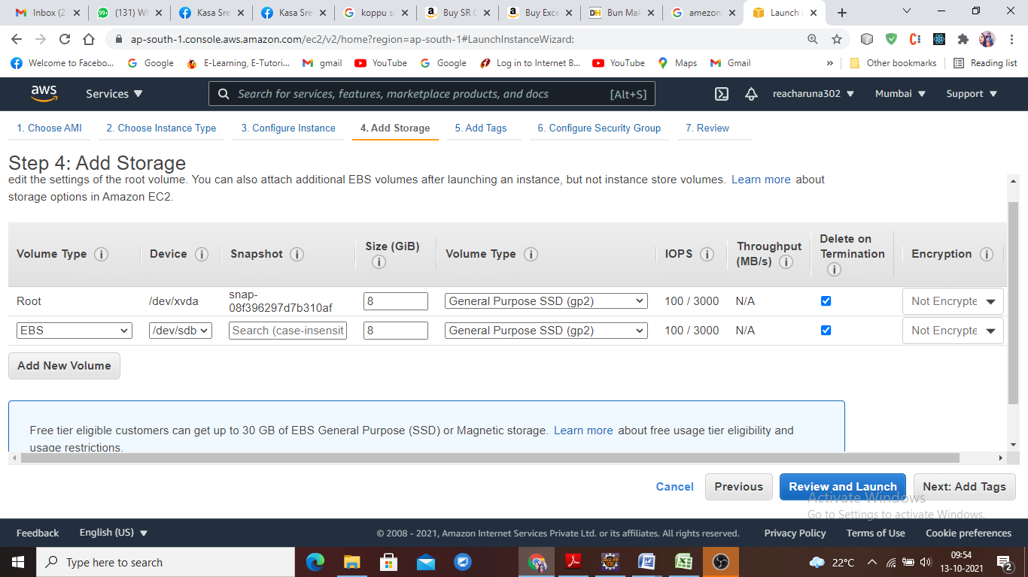

Step 5: Add Tags

A tag consists of a case-sensitive key-value pair. For example, you could define a tag with key = Name and value = Webserver.  
A copy of a tag can be applied to volumes, instances or both.  
Tags will be applied to all instances and volumes

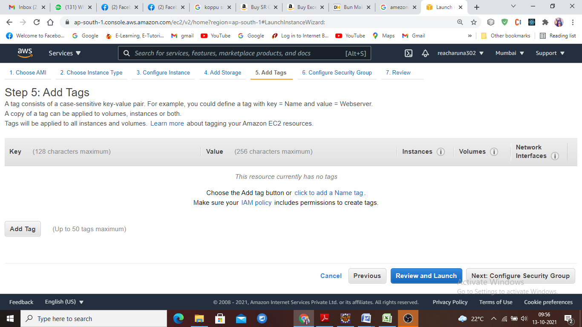

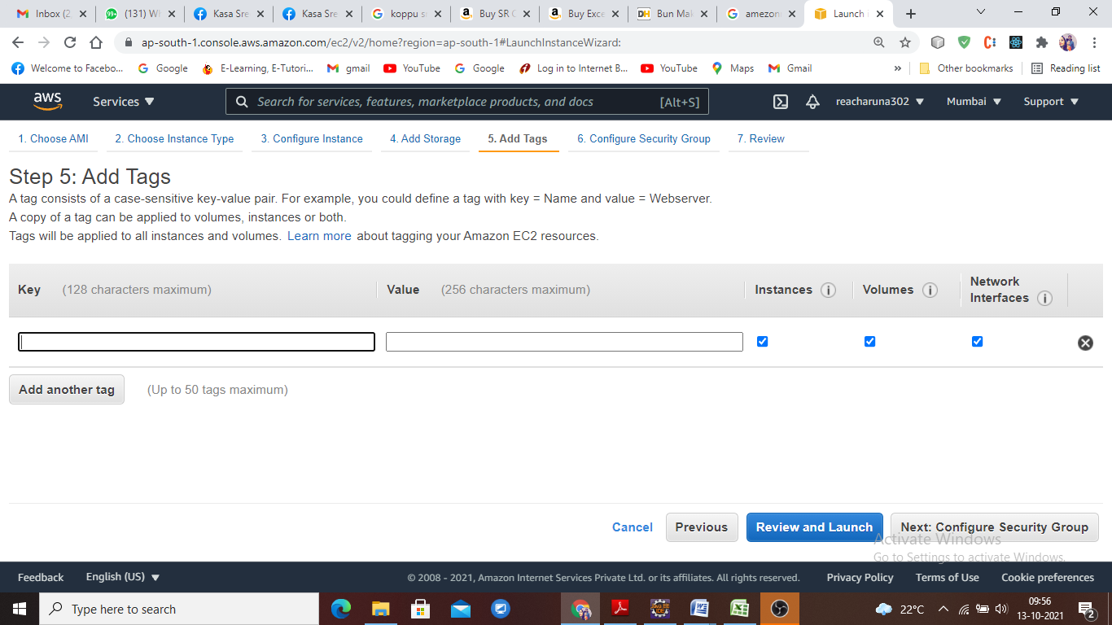

Step 6: Configure Security Group

A security group is a set of firewall rules that control the traffic for your instance. On this page, you can add rules to allow specific traffic to reach your instance. For example, if you want to set up a web server and allow Internet traffic to reach your instance, add rules that allow unrestricted access to the HTTP and HTTPS ports. You can create a new security group or select from an existing one below.

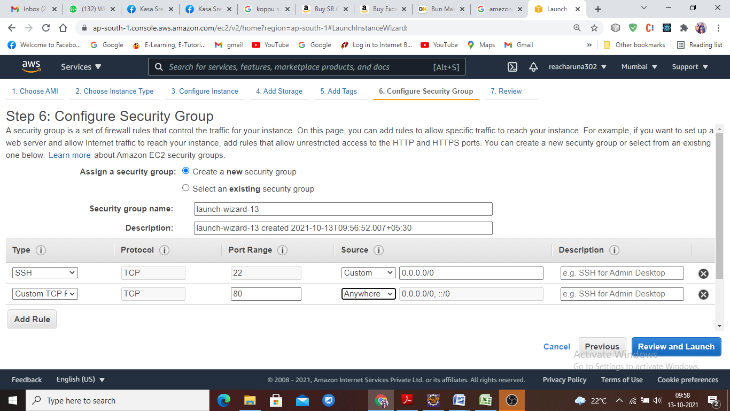

Step 7: Review Instance Launch

Please review your instance launch details. You can go back to edit changes for each section. Click **Launch** to assign a key pair to your instance and complete the launch process.

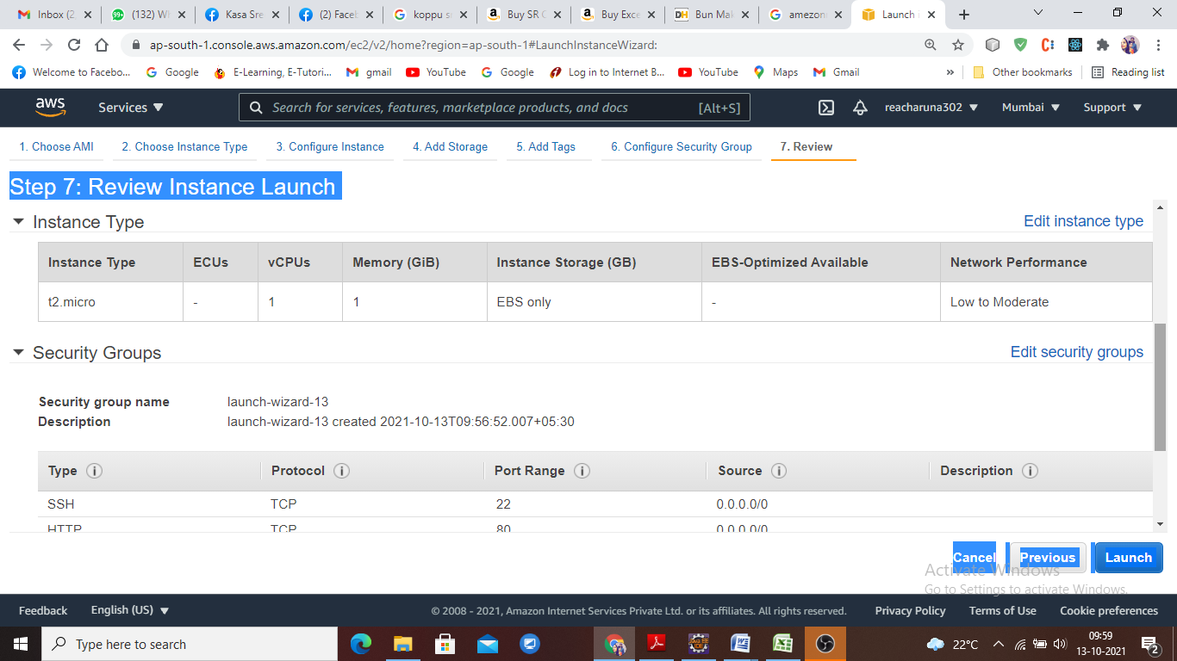

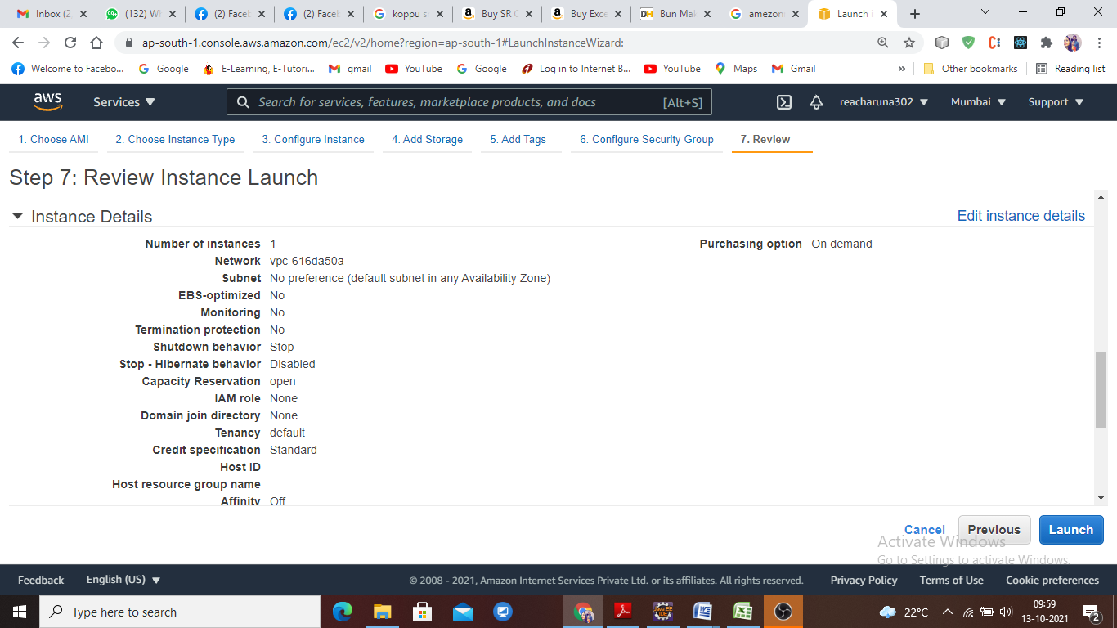

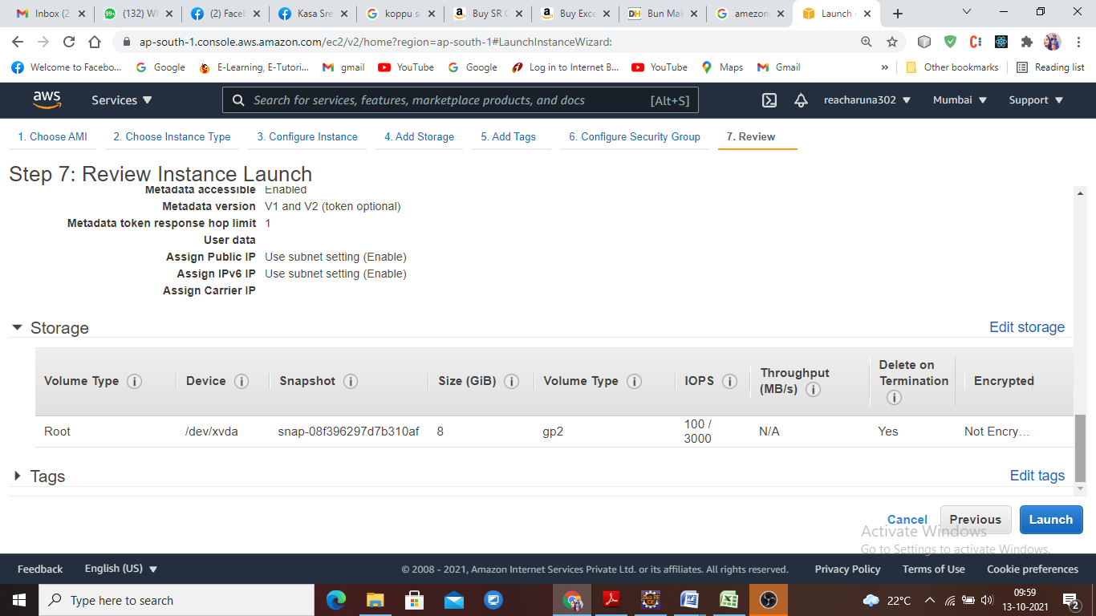

The Launch

Key pair creation to access AWS instance

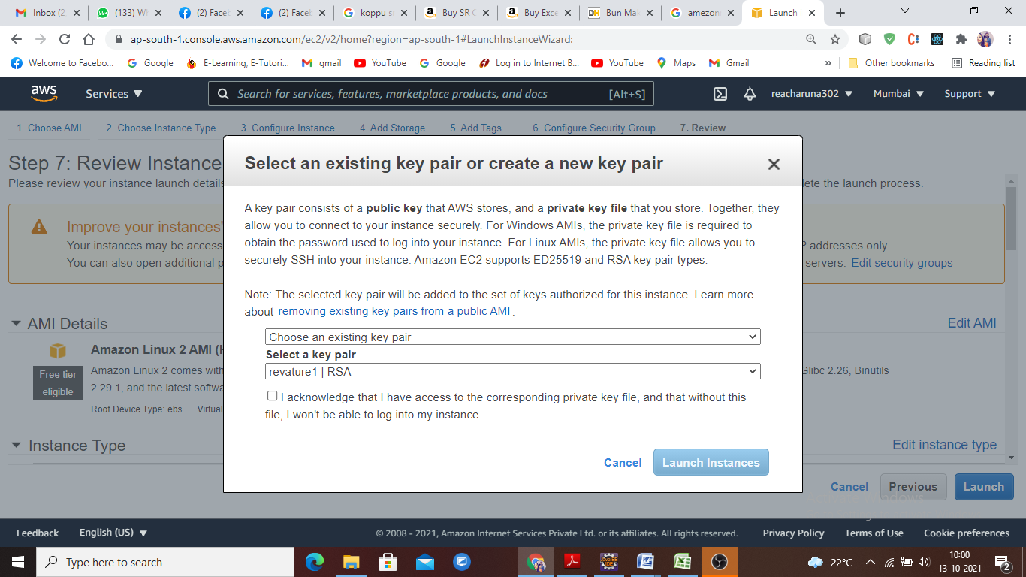

Puttygen:

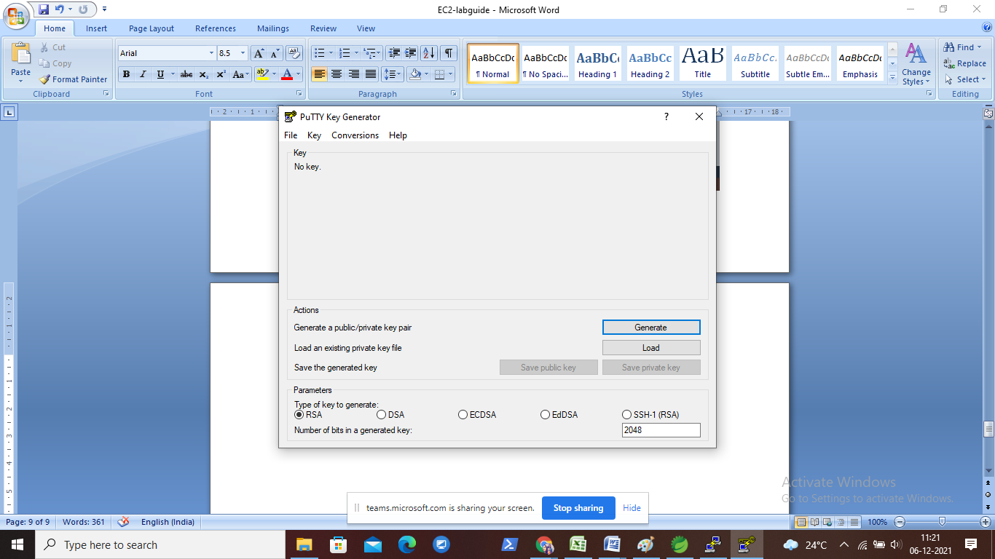

Click on load and select the downloaded pem file...all files

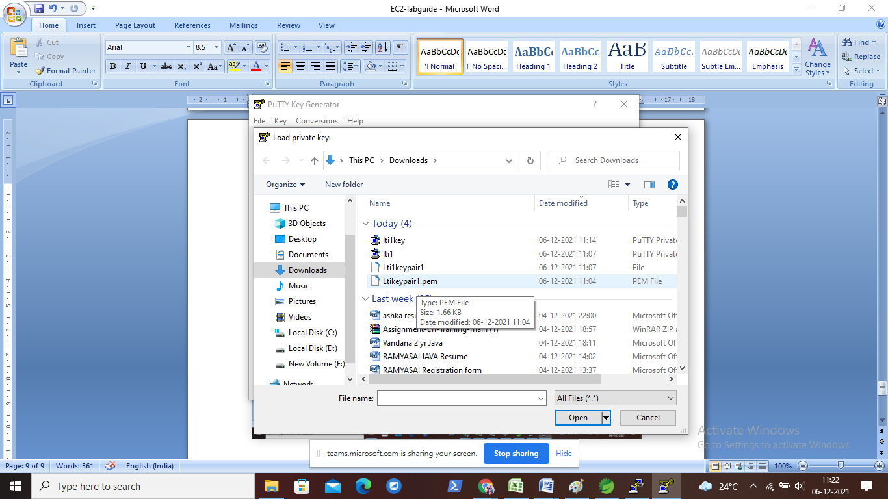

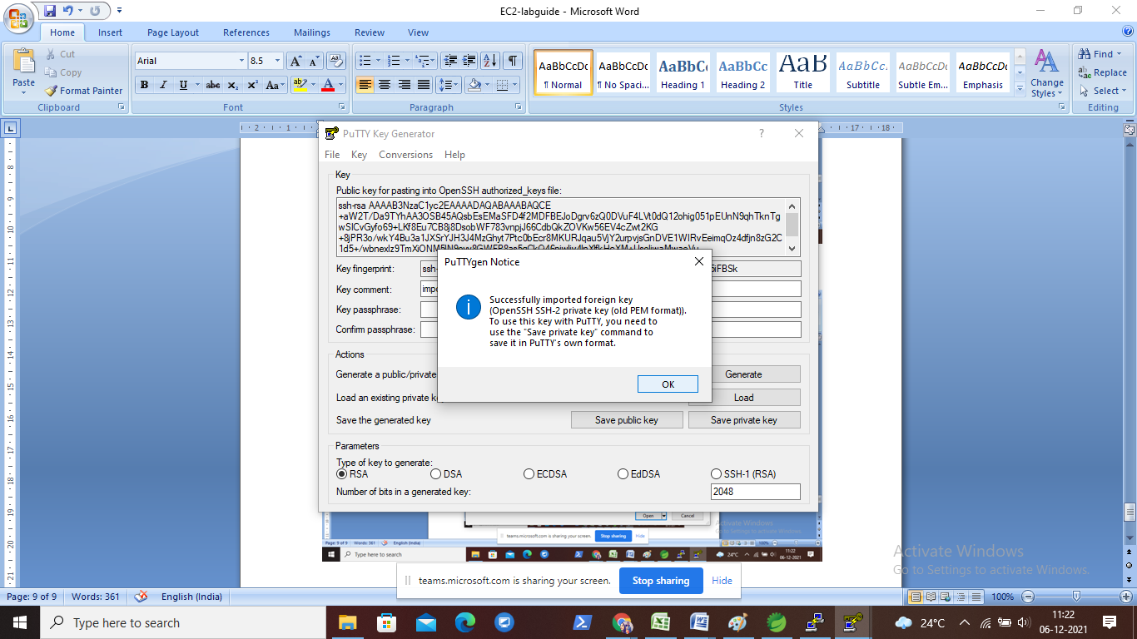

Save as Privatekey

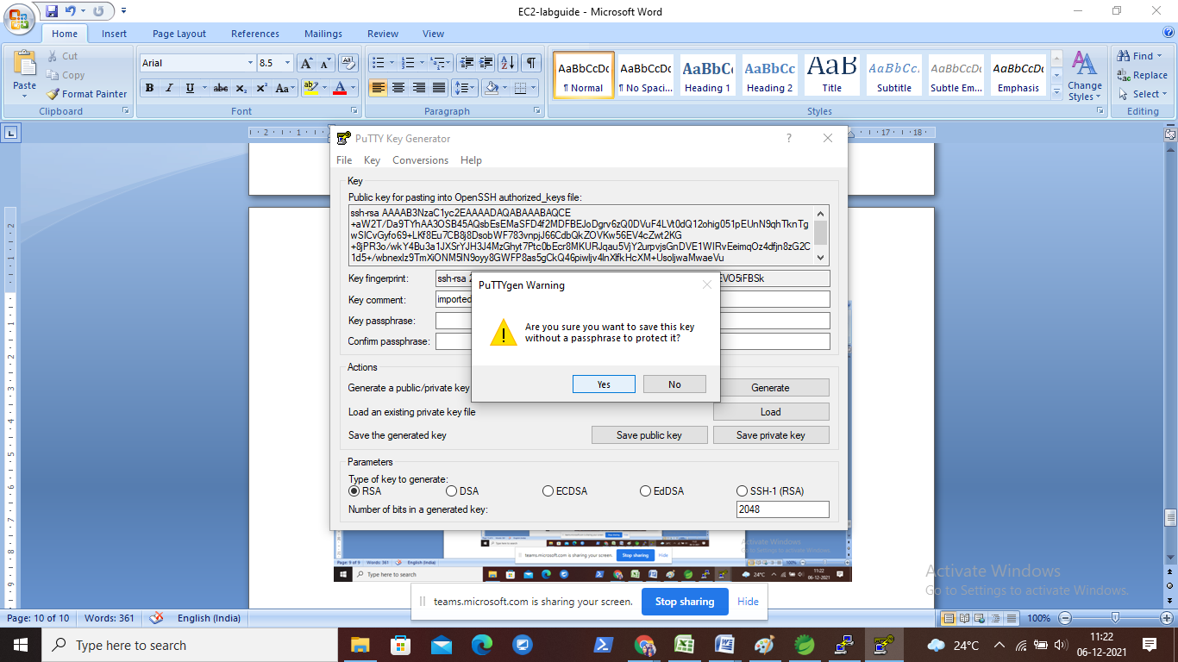

**Give some name.**

Ppk file is generated.

Open putty: copy Ec2 instance id

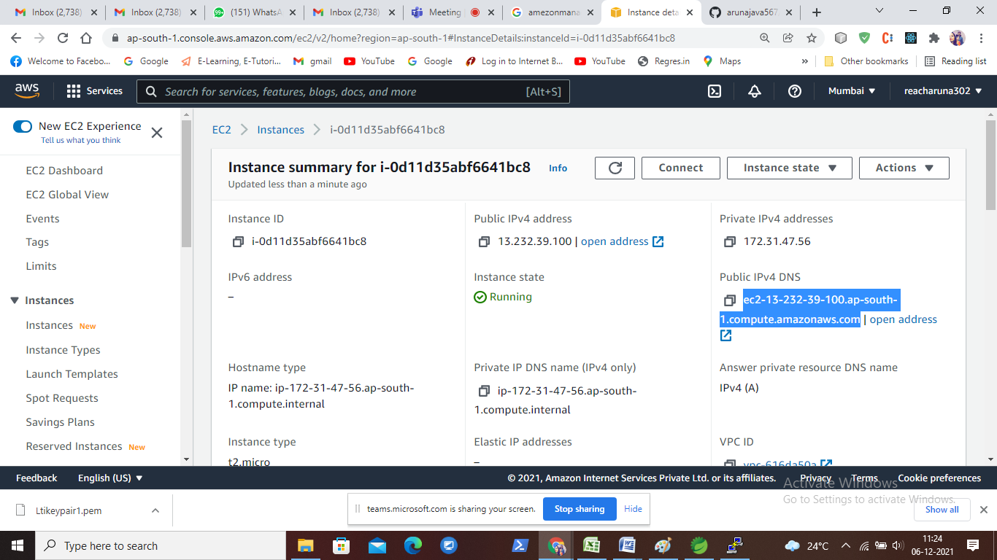

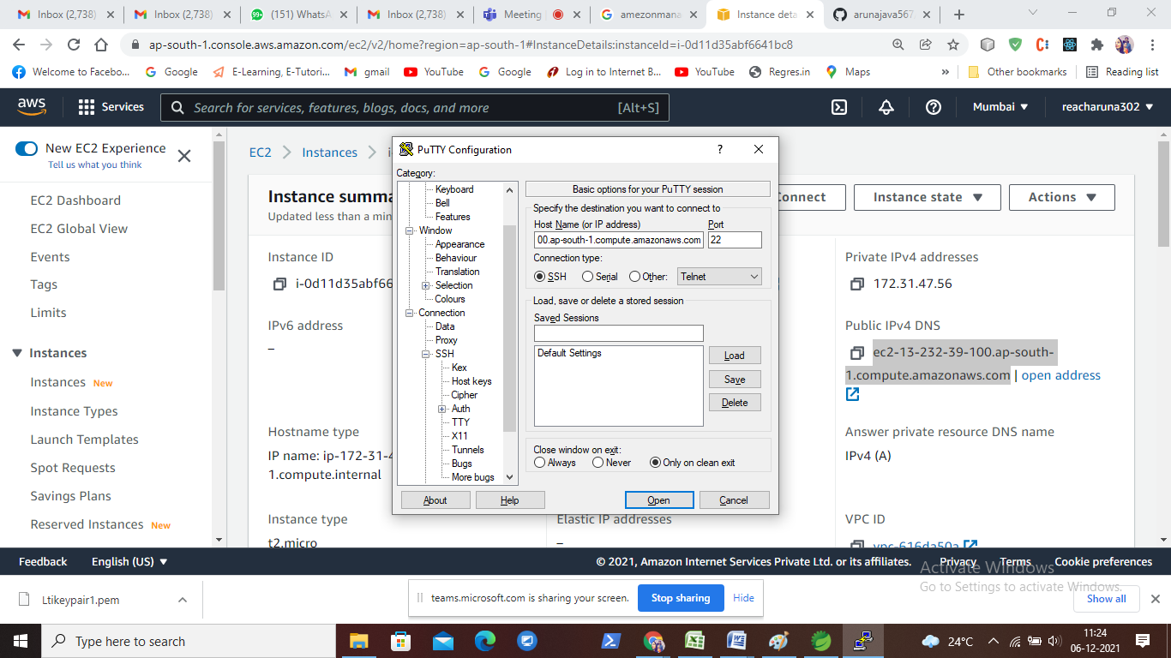

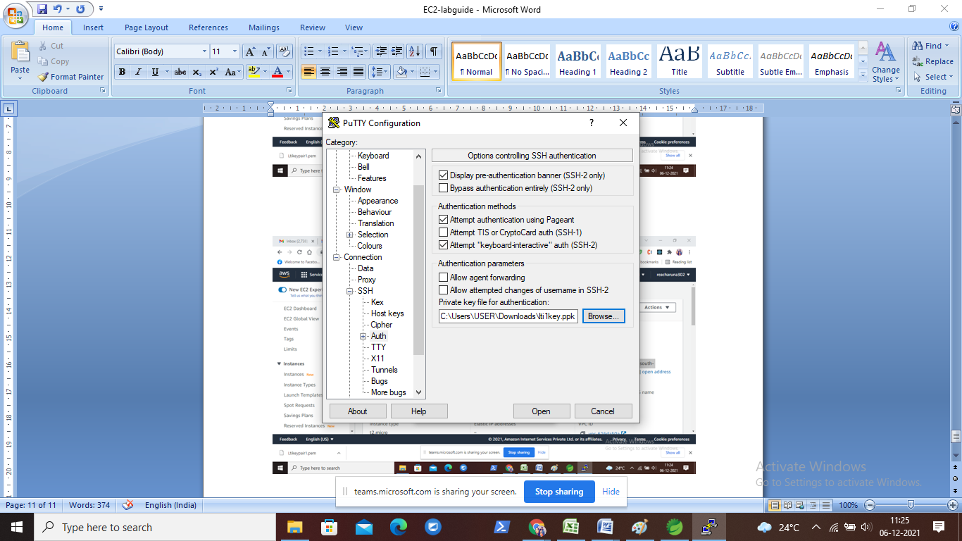

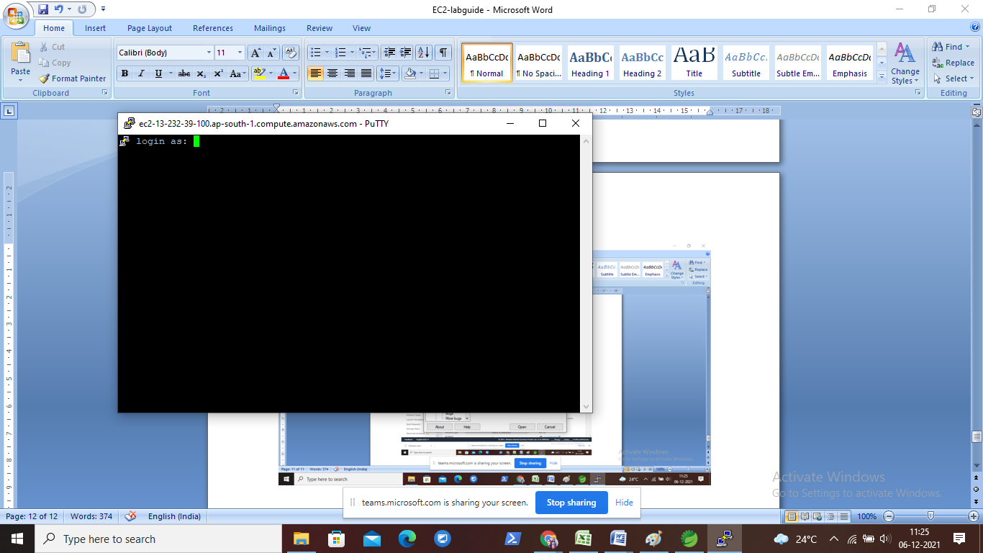

Login as ec2-user

